Databases Foundations I

Workshop No. 1 - Entity-Relationship Model

Andres Sneyder Castellanos Vivas Cod. 20191005108

Eng. Carlos Andrés Sierra, M.Sc.

Computer Engineering

Universidad Distrital Francisco José de Caldas

1. Write the user stories you think could support your design.

- As a user, I wish to be able to have multiple accounts simultaneously on the platform.

- As a user, I should be able to subscribe to several channels from that account.

- As a user, I should be able to generate comments within the videos I watch.

- As a user, I should be able to view the history of videos I've watched in case I want to replay any of them.

- As a user, I wish to be able to add videos to my profile and either make them public to share with others or keep them private for myself.

- As a user, I wish to be able to perform searches for both videos and user profiles.

- As a user, I wish to indicate likes or dislikes reactions on comments.

-As a user, I want to be able to bookmark videos to watch later or save them to a playlist.

-As a user, I want to be able to share videos on my social networks or other platforms.

2. Write down the 10 steps methodology to get the Data Structure Entity-Relationship

Model.

1. Define Entities

E1. User

E2. Videos

E3. Reactions

E4. Profiles

E5. Playlist

E6. Searcher

E7. Subscriptions

E8. Connections

1. Define Attributes per Entity.

E1. -> Name, Email, Phone, Profiles, Playlist, Subscriptions, Connections, Videos.

E2. -> Name, Dislikes, Likes, Comments, Playlist, Description.

E3. -> Likes, Dislikes, Comments, Videos.

E4. -> User, Name, Email, Phone, Profiles, Playlist, Subscriptions, Connections, Videos.

E5. -> Videos, Profiles.

E6. -> Profiles, Videos, Playlist.

E7. -> User, Profiles.

E8. -> Profiles

1. Define Relationships.

|  |  |  |  |  |  |  |  |  |
| --- | --- | --- | --- | --- | --- | --- | --- | --- |
|  | E1 | E2 | E3 | E4 | E5 | E6 | E7 | E8 |
| E1 |  |  |  |  |  |  |  |  |
| E2 |  |  |  |  |  |  |  |  |
| E3 |  |  |  |  |  |  |  |  |
| E4 |  |  |  |  |  |  |  |  |
| E5 |  |  |  |  |  |  |  |  |
| E6 |  |  |  |  |  |  |  |  |
| E7 |  |  |  |  |  |  |  |  |
| E8 |  |  |  |  |  |  |  |  |

1. Define Relationships Types.

E1  E2

E1  E4

E1  E5

E1 E6

E1 E7

E1 E8

E2  E3

E2 E5

E2  E6

E3  E2

E3  E5

E4  E1

E4  E5

E4 E6

E4 E7

E4 E8

E5 E2

E5 E1

E5  E2

E5  E3

E5 E4

E5 E6

E6  E1

E6  E2

E6  E4

E6  E5

E7 E4

E7 E1

E8 E4

E8 E1

1. First Entity - Relationship Draw

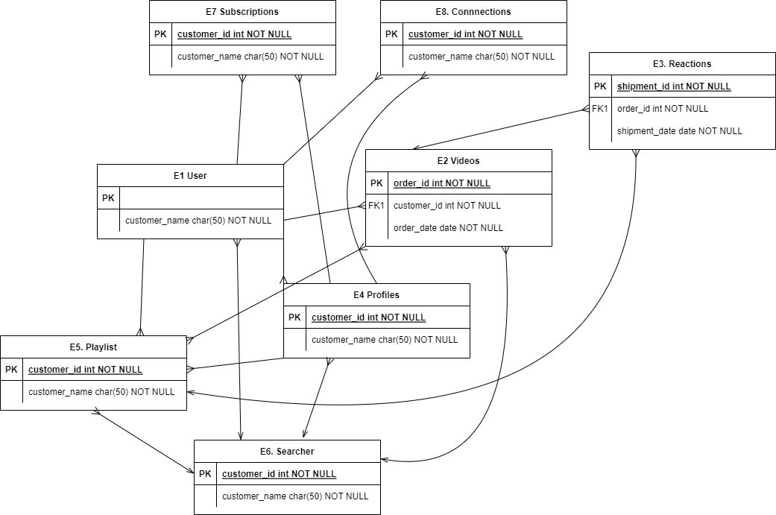

1. First Split Many-to-Many Relationships

Rel_E2_E3:

FK Id Videos

Fk Id Playlist

1. Second Entity-Relationship Draw

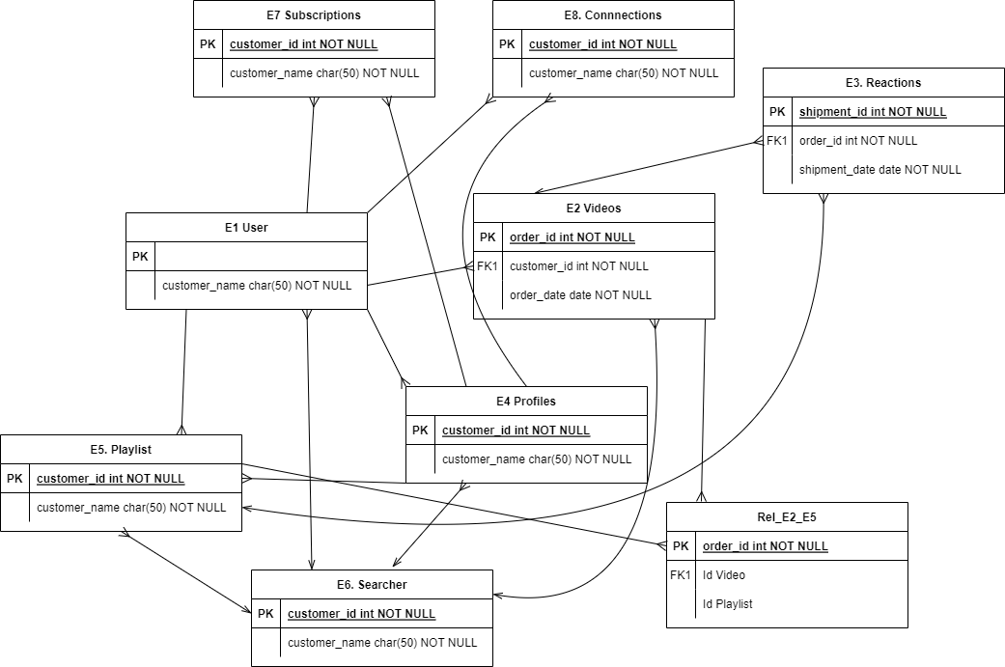

1. Write any technical decision/consideration you made in the design process.

During the elaboration process, considerations were taken such as profiles in addition to users, the generation of reactions for the videos, the analysis of relationships between entities, and the interaction among entities and user stories.

1. Write any concern or challenge you have completed the test.

The biggest challenge was time and the correct elaboration of the entities, as well as the generation of the data and the attributes of each entity, along with their relationships. Difficulty also arose in generating the elements of each relationship and tabulating them accordingly.